The diagram below shows the manufacturing process for making sugar from sugar cane.
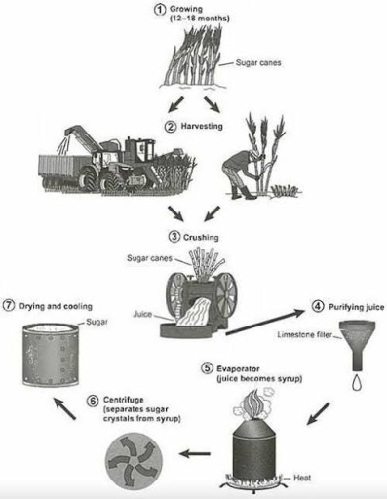
The diagram illustrates the sequence of stages involved in the production of sugar from sugarcane.
Overall, the process comprises seven distinct phases, beginning with the cultivation and harvesting of sugarcane and culminating in the drying and cooling of refined sugar crystals, with each stage playing a vital role in achieving final outcome.
At the outset, sugarcane is grown in fields for approximately 12 to 16 months until it reaches maturity. Once fully grown, it is harvested either manually using workers with machetes or mechanically with specialized machinery. The harvested cane is then transported to the crushing stage, where it is fed through large rollers to extract the juice.
In the subsequent stage, the raw juice is purified by passing it through a limestone filter, which removes impurities. The filtered liquid is then heated to produce a thick syrup. At the penultimate stage, the syrup undergoes centrifugation, where it is spun at high speed to separate sugar crystals from the liquid content.
In the final stage, the extracted crystals are transferred to a drying and cooling chamber, where they solidify into granulated sugar, ready for packaging and distribution.

